French is Fun Day 2022-2023
Learning Through Activities

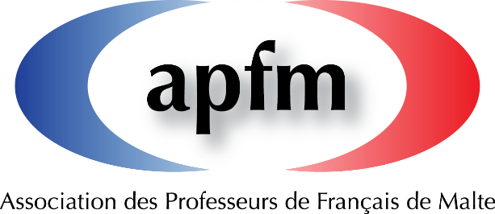

Data Protection Consent Form
to be filled by Student’s Parent/Guardian

Name of Participating Student: .......................................................................................

School: ...........................................................................................................................................

By signing this document I declare that I agree to the following statements:

- I allow my daughter/son to participate in the “French is Fun Day – Learning through activities” and to be filmed during a school activity involving the learning of the French language or culture.
- I hereby authorise my daughter/son’s teacher to capture, process and use photography and video imaging taken during the school activity for educational purposes in order to promote positive attitudes towards the French language and culture.
- I am aware that the organisers plan to publish such images (web and other media) in several reports pertaining to the project and use such photos/videos for educational purposes and for future promotion of such events.

Signature of Parent/Guardian: ………………………………………………

ID Card No. : …………………………………………………………………………...

The information collected on this form shall be processed in accordance with the Data Protection Act 2001. The contents in this document are confidential and intended solely for the use of this competition and will not be copied or disclosed without the person’s consent to anyone.

