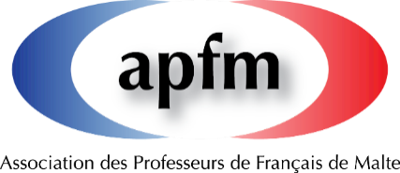

French is Fun Day 2022-2023
Apprendre à travers des activités
 | Cette activité sera liée cette année scolaire au Prix Anne Borg. Pour plus de détails voir www.apfmalta.com ou la page FB de l’APFM  PRIX  ANNE BORG | 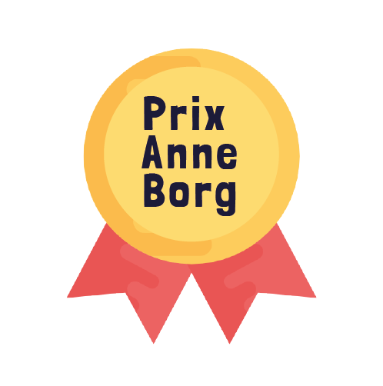
Nom du/des professeur/s participant à la journée French is Fun : ………………………………………………………………………………………………………………………………………………………………………………………………………………………………………………………………………………………………………………………………………………………………………………………………………………………………………………………………………………………
Nom et adresse de l’établissement scolaire :
…………………………………………………………………………………………………………………………………………………………………………………………………………………………………………………………………………………………………………………………………………………………………………………………………………………………………………………………………………………………………………………………………………………………………………………………………………………………………………………….
Nom de la/des classe/s participant à la journée French is Fun :
…………………………………………………………………………………………………………………………………………………………………………………………………………………………………………………………………………………………………………………………………………………………………………………………………………………………………………………………………………………………………………………………………………………………………………………………………………………………………………………….
Date de la journée French is Fun :
…………………………………………………………………………………………………………………………………………………………...

Courte description de la/des activité/s :
…………………………………………………………………………………………………………………………………………………………………………………………………………………………………………………………………………………………………………………………. …………………………………………………………………………………………………………………………………………………………….……………………………………………………………………………………………………………………………………………………………. …………………………………………………………………………………………………………………………………………………………………………………………………………………………………………………………………………………………………………………………

